EXPERIMENT 1
Aim: Simulation of Single server Single Queueing System
SIMULATE
GENERATE 4,1 ; cust arrive every 4+-1 min
QUEUE LINE ; a queue called line exists
SEIZE B ; barber is busy
DEPART LINE ; the cust departs the line when service starts
ADVANCE 4,3 ; service time can be 4+-3
RELEASE B ; barber is free
TERMINATE 1
START 250
Theory: A single server queuing system consists of customers arriving at a service
facility, waiting in a queue if the server is busy
and receiving the service once the server is free and then departing.
The system consists of arrival rate, service rate, queue length and waiting time.
COMMANDS:
1. GENERATE: creates entities at specified intervals/ inter-arrival times.
2. ADVANCE: simulate the passage of time during which an entity is in transit or being processed.
3. SEIZE: allocates a resource to an entity. If unavailable, the entity has to wait in a queue.
4. RELEASE: frees the resource or the server after the service is completed, making it available
to serve the next entity.
5. TERMINATE: ends the process of an entity or stops the simulation based on a condition.
Scenario Overview:
• The Barber Shop: The shop has a single barber (server) and a single line (queue) where
customers wait for service.
This type of system is known as an M/M/1 queue, where:
o M stands for "Markovian" or memoryless, meaning the arrival times and service times follow
exponential distributions.
o 1 refers to a single server, in this case, the barber.
Key Components:
1. Customers: Customers arrive at the barber shop at random intervals. When they arrive,
they enter the queue and wait for the barber to become available
if the barber is busy.
2. Barber (Server): The barber is responsible for serving customers. The barber can only
serve one customer at a time.
3. Queue (Line): If the barber is busy serving another customer, arriving customers will
have to wait in the queue.
Conclusion:
Total customers generated: 256
Customers served successfully: 250
Single server B utilization = 0.969 (96.9%), meaning the server was busy almost all the time.
Average service time ≈ 3.97 minutes
Maximum queue length reached 7 customers
Average waiting time in queue ≈ 7.4 minutes
The GPSS simulation represents a single-server queue system.
The server utilization was very high (96.9%), showing that the server remained busy most of the time.
Customers experienced moderate waiting in the queue, with an average waiting time of about 7.4 minutes.
Hence, the system is efficient but heavily loaded and may require an additional server to
reduce waiting time. Hence, the system is efficient but heavily loaded and may require an additional server to reduce waiting time.

EXPERIMENT 2
Aim:
Simulation of Multiple Server Single Queueing System
CODE:
SIMULATE
STORAGE BARBER 3 ;Creates 3 servers/resources
GENERATE 10,5
QUEUE LINE
ENTER BARBER ;Customer occupies one available server
DEPART LINE
ADVANCE 8,4
LEAVE BARBER ;Frees one server
TERMINATE
GENERATE 480 ;480 MINS OR 4 HOUR SIMULATION
TERMINATE 1
START 1
--
Theory:

A multiple server single queueing system consists of customers arriving at a service
facility containing multiple servers. Customers wait in a common queue if all servers
are busy and receive service from the next available server before departing from the system.

The system consists of:

Arrival rate
Service rate
Queue length
Waiting time
Number of servers
COMMANDS:
GENERATE
Creates customers/entities at specified inter-arrival times.
QUEUE
Places arriving customers into the waiting line.
ENTER
Allocates one unit of storage/server to a customer.
DEPART
Removes the customer from the queue when service begins.
ADVANCE
Simulates service time.
LEAVE
Releases the occupied server after service completion.
TERMINATE
Removes the customer from the system or ends the simulation.
STORAGE
Defines multiple identical servers/resources.
Scenario Overview:
The Barber Shop:

The barber shop contains multiple barbers (servers) and a single common
queue where customers wait for service.

This system is known as an M/M/C queue, where:

M represents Markovian arrival distribution (random arrivals)
M represents Markovian service distribution (random service times)
C represents multiple servers
Key Components:
1. Customers

Customers arrive randomly at the barber shop. If all servers are busy,
customers wait in the common queue.

2. Servers (Barbers)

There are multiple barbers available to serve customers simultaneously.
Each barber can serve one customer at a time.

3. Queue (Line)

A single waiting line is maintained. Customers are served on a first-come
first-served basis whenever a server becomes free.

Conclusion

The GPSS simulation represents a Multiple Server Single Queue system with 3 servers (barbers)
and one common waiting line.

During the 480-minute simulation:

Total customers generated: 47
Customers served successfully: 46
Number of servers available: 3
Storage utilization = 0.256 (25.6%)
Average number of busy servers ≈ 0.768
Maximum queue length reached = 1 customer
Average waiting time in queue = 0 minutes

The report shows that the system handled customers efficiently with
very little queue formation. Since three servers were available, customers received
service immediately in most cases. The server utilization was low,
indicating that the system had more than enough service capacity for the incoming customers.

EXPERIMENT 3
aim: Simulation of Inventory System

SIMULATE
WORKER STORAGE 3

GENERATE 18,6
QUEUE LINE
ENTER WORKER
DEPART LINE
ADVANCE 16,4
LEAVE WORKER
TERMINATE

GENERATE 240
TERMINATE

GENERATE 480
TERMINATE 1

START 1

Theory:

An inventory system is used to manage and control the storage, movement, and availability of goods or
materials in an organization. It helps businesses maintain sufficient stock levels while reducing shortages and excess inventory.

In this simulation, multiple workers (servers) process inventory demands from customers.
Customers arrive randomly and wait in a common queue if all workers are busy.
The system also includes periodic restocking events.

The system mainly consists of:

Arrival rate
Service rate
Queue length
Waiting time
Number of workers/servers
COMMANDS:
GENERATE
Creates transactions or customers at specified time intervals.
QUEUE
Places customers in the waiting line.
ENTER
Allocates one available worker/server from storage.
DEPART
Removes customers from the queue once service begins.
ADVANCE
Simulates service or processing time.
LEAVE
Releases the worker/server after service completion.
TERMINATE
Removes the transaction from the system or stops the simulation.
STORAGE
Defines multiple identical servers/resources.
Scenario Overview:
Inventory Management System

The system contains:

Multiple workers (servers)
A single waiting queue
Periodic restocking process

Customers generate inventory requests randomly. If all workers are busy, incoming requests wait in the
queue until a worker becomes available.

This system behaves similarly to an M/M/C queue, where:

M indicates random arrivals
M indicates random service times
C indicates multiple servers
Key Components:
1. Customers

Customers generate inventory demands and enter the queue when workers are busy.

2. Workers (Servers)

Three workers process inventory requests simultaneously. Each worker handles one customer at a time.

3. Queue (Line)

A single common queue is maintained for waiting customers.

4. Restocking Process

Restocking transactions occur periodically to represent supply replenishment.

Conclusion:

The GPSS simulation represents a multiple-server inventory management system with 3 workers and a single queue.

During the 480-minute simulation:

Total customers generated: 26
Customers served successfully: 25
Number of workers available: 3
Worker utilization = 0.288 (28.8%)
Average number of busy workers ≈ 0.863
Maximum queue length reached = 1 customer
Average waiting time in queue = 0 minutes

The report shows that the inventory system handled customer requests efficiently with minimal
queue formation and no significant waiting time. Since multiple workers were available,
most requests were processed immediately. The worker utilization was low, indicating that the system
had sufficient processing capacity for the incoming inventory demands.

EXPERIMENT 4
Aim:
Simulation of Quality Control System
SIMULATE
WORKER STORAGE 3
GENERATE 20
QUEUE QCQUEUE
ENTER WORKER
DEPART QCQUEUE
ADVANCE 12
LEAVE WORKER
TERMINATE
GENERATE 300
TERMINATE
GENERATE 480
TERMINATE 1
START 1
Theory:

A quality control system is used in industries to inspect products and ensure they meet required
standards before delivery or sale. Products arriving for inspection are checked by available inspectors
or workers. If all inspectors are busy, products wait in a queue until service becomes available.

This simulation models a multiple-server quality control system with a single queue.

The system mainly consists of:

Product arrival rate
Inspection/service time
Queue length
Waiting time
Number of inspectors/workers
COMMANDS:
GENERATE
Creates products arriving for inspection.
QUEUE
Places products into the waiting line.
ENTER
Allocates one available worker/server.
DEPART
Removes products from the queue once inspection starts.
ADVANCE
Simulates inspection time.
LEAVE
Releases the worker after inspection.
TERMINATE
Removes the product from the system or stops simulation.
STORAGE
Defines multiple identical workers/servers.
Scenario Overview:

The quality control system contains:

Three inspectors/workers
One common inspection queue
Continuous product arrivals

Products arrive randomly for inspection. If all inspectors are busy, products wait in the queue
until one worker becomes available.

This behaves like an M/M/C queueing system, where:

M = random arrivals
M = random inspection times
C = multiple servers
Key Components:
1. Products

Products arrive for inspection and wait if inspectors are busy.

2. Workers/Inspectors

Three inspectors perform quality checks simultaneously.

3. Queue

A single waiting line stores products waiting for inspection.

4. Inspection Process

Products undergo quality checking before leaving the system.

Small Conclusion Template
During the 480-minute simulation:

Total products inspected: 23
Number of workers available: 3
Worker utilization = 0.192 (19.2%)
Average number of busy workers ≈ 0.575
Maximum queue length reached = 1 product
Average waiting time in queue = 0 minutes
The GPSS simulation represents a multiple-server quality control system with three inspectors and one common queue.
Products were inspected efficiently with minimal waiting time due to the availability of multiple workers.
The system showed smooth workflow and effective utilization of inspection resources.

EXPERIMENT 5
Aim:
Simulation of Washing Machine System
SIMULATE
WASHER STORAGE 3
GENERATE 15 ;Clothes arrive every 15 minutes
QUEUE WASHQ
ENTER WASHER
DEPART WASHQ
ADVANCE 15
LEAVE WASHER

QUEUE RINSEQ
ENTER WASHER
DEPART RINSEQ
ADVANCE 10
LEAVE WASHER

QUEUE SPINQ
ENTER WASHER
DEPART SPINQ
ADVANCE 5
LEAVE WASHER
TERMINATE
GENERATE 480
TERMINATE 1
START 1
Theory:

A washing machine system is used in laundry services to process clothes through multiple stages such
as washing, rinsing, and spinning. Customers arrive with clothes for cleaning, and available washing
machines process them sequentially.

If all washing machines are busy, arriving clothes wait in a queue until a machine becomes available.

This simulation models a multiple-server laundry system with three washing machines and separate queues
for each processing stage.

COMMANDS:
GENERATE
Creates clothes/customers entering the system.
QUEUE
Places customers into a waiting line.
ENTER
Allocates one available washing machine.
DEPART
Removes customers from the queue when processing begins.
ADVANCE
Simulates processing time.
LEAVE
Releases the washing machine after processing.
TERMINATE
Removes customers from the system or stops simulation.
STORAGE
Defines multiple washing machines/resources.
Scenario Overview:

The laundry service contains:

Three washing machines
Separate queues for washing, rinsing, and spinning
Sequential processing stages

Each customer undergoes:

Washing
Rinsing
Spinning

Customers wait whenever all washing machines are occupied.

The system behaves like a multi-stage multiple-server queueing system.

Key Components:
1. Customers (Clothes)

Clothes arrive randomly for laundry service.

2. Washing Machines (Servers)

Three washing machines process clothes simultaneously.

3. Queues

Separate waiting queues are maintained for:

Washing
Rinsing
Spinning
4. Processing Stages

Clothes pass through washing, rinsing, and spinning sequentially before leaving the system.

Small Conclusion Template
During the 480-minute simulation:

Total clothes/customers processed: 30
Number of washing machines available: 3
Washer utilization = 0.635 (63.5%)
Average number of busy washers ≈ 1.906
Maximum queue length in each stage = 1 customer
Average waiting time in queues = 0 minutes
The GPSS simulation represents a multiple-server washing machine system with three washing machines
and separate queues for each stage. Clothes were processed efficiently through washing, rinsing, and
spinning operations with minimal waiting time. The system showed smooth workflow and effective utilization of washing machines.

Aim:
Simulation of Airline Passenger Processing System
SIMULATE
; Passenger Arrival
GENERATE 5

; Check-In Process
QUEUE CHECKINQ
SEIZE CHECKIN
DEPART CHECKINQ
ADVANCE 4
RELEASE CHECKIN

; Security Check
QUEUE SECURITYQ
SEIZE SECURITY
DEPART SECURITYQ
ADVANCE 3
RELEASE SECURITY

; Boarding
ADVANCE 2
TERMINATE

; Facilities
CHECKIN EQU 10000
SECURITY EQU 10001

; Simulation Timer
GENERATE 480
TERMINATE 1

START 1
Theory:

An airline passenger processing system manages passengers through different stages such
as check-in, security screening, and boarding. Passengers arrive at the airport, wait in
queues if service counters are busy, and proceed sequentially through each stage before boarding.

This simulation models the passenger flow through:

Check-in counters
Security checkpoints
Boarding process

The system helps analyze:

Queue length
Waiting time
Resource utilization
Passenger flow efficiency
COMMANDS:
GENERATE
Creates passenger arrivals at specified intervals.
QUEUE
Places passengers into waiting lines.
SEIZE
Allocates a service facility to a passenger.
DEPART
Removes passengers from the queue after service begins.
ADVANCE
Simulates processing time.
RELEASE
Frees the facility after service completion.
TERMINATE
Removes the passenger from the system or stops the simulation.
EQU
Defines facility identifiers.
Scenario Overview:

The airline passenger processing system contains:

One check-in counter
One security checkpoint
Sequential passenger movement

Passengers arrive every 5 minutes and proceed through:

Check-in
Security screening
Boarding gate access

If the facilities are busy, passengers wait in queues until service becomes available.

Key Components:
1. Passengers

Passengers arrive randomly and move through all airport processing stages.

2. Check-In Counter

Handles ticket verification and baggage processing.

3. Security Checkpoint

Performs passenger security screening.

4. Queues

Separate queues are maintained for:

Check-in
Security
5. Boarding Process

Passengers proceed to boarding after completing all checks.

Small Conclusion Template

The GPSS simulation represents an airline passenger processing system with check-in and
security stages. Passengers were processed sequentially through each stage with queue management
and service facilities. The simulation helps evaluate passenger flow, waiting time, and resource utilization for efficient airport operations.

EXPERIMENT 7
Aim:
Simulation of Supermarket System
SIMULATE
GENERATE 6
QUEUE BILLINGQ
SEIZE BILLING
DEPART BILLINGQ
ADVANCE 5
RELEASE BILLING

ADVANCE 2
TERMINATE

BILLING EQU 10000

GENERATE 480
TERMINATE 1
START 1
Theory:

A supermarket system consists of customers arriving at billing counters to complete purchases.
Customers wait in a queue if the billing counter is busy and receive service once the counter becomes available.

This simulation helps analyze:

Customer waiting time
Queue length
Billing counter utilization
Customer flow efficiency

The system follows a single-server queueing model where one billing counter serves customers sequentially.

COMMANDS:
GENERATE
Creates customer arrivals at specified intervals.
QUEUE
Places customers into the waiting line.
SEIZE
Allocates the billing counter to a customer.
DEPART
Removes customers from the queue after service begins.
ADVANCE
Simulates billing and exit processing time.
RELEASE
Frees the billing counter after service completion.
TERMINATE
Removes the customer from the system or stops simulation.
EQU
Defines the billing counter facility.
Scenario Overview:

The supermarket system contains:

One billing counter
One billing queue
Continuous customer arrivals

Customers arrive every 6 minutes, wait in the billing queue if necessary, complete billing, and then exit the supermarket.

Key Components:
1. Customers

Customers arrive randomly for billing service.

2. Billing Counter

Processes customer billing one at a time.

3. Queue

Customers wait in the billing queue if the counter is busy.

4. Exit Process

Customers leave the supermarket after billing is completed.

Small Conclusion Template
The GPSS simulation represents a supermarket billing system with a single billing counter and one queue.
Customers were processed sequentially through the billing system. The simulation helps analyze customer
waiting time, queue behavior, and billing counter utilization for efficient supermarket operations.

Q1. Define system and system environment in the context of simulation. Explain with one suitable real-life example.
Ans: A system is a collection of interrelated components (entities, attributes, activities and resources) that work together to achieve a certain goal or objective. The simulation model is a simplified representation of this system.
Ex: banking system, traffic system, hospital system.
A system environment consists of all external factors and conditions that lie outside the system but directly influence its behaviour. The environment provides inputs to the system and the system may produce outputs that affects the environment, but internal changed within the system don’t alter the environment.
Ex: customers affecting bank system
EXAMPLE: CAR WASH SYSTEM
System:
- Entities: cars
- Attributes: size of car, type of wash
- Resources: wash tunnel, soap sprayer, dryer, water, workers.
- Process: arrival, payment, pre-rinse, soap application, brush wash, rinse, dry, exit.
- Objective: minimise average wait time or maximise car washed per hour.
Environment:
- Arrival pattern
- Weather condition
- Customer behaviour
- Electric supply fluctuation
Q2. Explain the models.
Ans: A model is a logical or mathematical abstraction of a real system that captures its core behaviour. using the model experiments are performed to study the system behaviour.
it includes:
Input variables: parameters that define the system
Output variable: parameters that measure the system
Mathematical or logical relationships: links inputs to outputs.
TYPES OF MODELS:
- PHYSICAL MODEL:
- A physical model is a tangible, real world replica of a system. It can be seen and touched.
Ex: miniature building, car, human heart etc.
- APPLICATION: architecture, medical education, mechanical design,
- ADVANTAGES: easy to understand and visualise, useful for teaching and demonstrating, helps in design understanding.
- DISADVANTAGES: can be expensive to build, scaling issue may affect accuracy, cannot always represent dynamic behaviour.
- MATHEMATICAL MODEL:
- It represents a system using equations, variable, formulas and probabilities.
- APPLICATIONS: AI, ML, data science, economics, simulation.
Ex: speed = distance/time, profit = revenue/cost.
- DETERMINISTIC MODEL: no randomness, same input gives same output. Ex: length*breadth = area
- STOCHASTIC MODEL: includes randomness and uncertainty, same input may give different output. Ex: customer arrival times, weather forecasting, stock market behaviour.
- ADVANTAGS: powerful and precise representation, useful in prediction and optimisation, can be efficiently processed by computers, forms the foundation of AI and ML.
- LIMITATIONS: requires strong mathematical knowledge, complex systems can be difficult to model, incorrect assumptions lead to wrong results.
- SIMULATION MODEL:
- It is a computer-based implementation of a system that imitates its behaviour over time. It allows experimentation without affecting the real system.
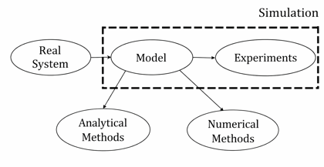
Ex: hospital operations, pilot training, road traffic
- CHARACTERISTICS: usually dynamic [changes with time], shows system behaviour under different conditions, allows ‘what-if’ analysis, helps compare multiple scenarios.
Ex: with 2 doc, avg waiting time = 30 mins. With 3 doc, avg waiting time = 20 mins.
Q3: STEPS INVOLVED IN SIMULATION STUDY
Ans: Simulation is a computer-based imitation of a real-world system or process where models are used to study behaviour, predict outcomes and test different scenarios and test decisions without affecting the actual system.
It is used to experiment safely, to reduce cost and time, predict future scenarios, train and plan before real execution.
it follows a systematic process:
- PROBLEM DEFINITION: clearly identify the problem, without clear problem- simulation becomes useless.
Ex: students are waiting for too long in canteen queue.
- SYSTEM UNDERSTANDING: understand how the real system works. Identify the entities (customers, machines, students), resources (staff, counters), process flow (who comes first, what happens next).
Ex: how students arrive-> how the order -> how food is served.
- MODEL DEVELOPMENT: model of the system is created; mathematical model, logical flow, computer simulation etc.
Ex: model canteen as: arrival rate of students, service time per student, number of counters.
- DATA COLLECTION: collect real data from the system. Good data= good simulation result.
Ex: avg arrival time, avg wait time, peak hour rush, resource availability.
- VERIFICATION AND VALIDATION: ‘are we building the model correctly?’ and ‘does the model behave like the real system?’
- Checks logic errors in model and compare simulation op with real data.
- SIMULATION EXECUTION: run the simulation and test on different scenarios.
Ex: what if more counters were there, what if arrival rate increased, what if staff reduced?
- RESULT ANALYSIS: analyse output using graphs, charts, reports and tables.
Ex: waiting time reduces from 15-6 mins when extra counter is added.
- IMPLEMENTATION: apply the best solution to the system.
Ex: one more counter was added to the cafeteria.
ADVANATGES:
- No risk to real system
- Saves cost compared to real experiments
- Complex systems can be analysed easily
- Multiple scenarios can be tested
- Improves decision making
- Useful in healthcare, AI, ML, business, traffic
DISADVANTAGE:
- Model development takes time
- Requires skilled EXPERTS
- Poor data gives wrong result
- Sw tools can be costly
- Wrong assumption= misleading decisions
Q4: What is Discrete Event Simulation (DES)
Ans: it is a type of simulation model where the state of a system changes only at distinct points in time, called events, rather than continuously. Between events the system remains unchanged.
TIME ADVANCES FROM ONE EVEN TO ANOTHER AND SKIPS THE INACTIVE PERIOD
Unlike continuous stimulation (tracking temperature second by second), DES jumps from one event to another, making it highly efficient for systems where changes happen at specific moments (ex, customer arriving, machine breaking, power cut)
KEY ELEMENTS:
- Entities: dynamic objects that move through the system and eventually exit. (customers, packets)
- Events: schedules events (service ends at 10pm), conditional events (if teller is free, and queue is not empty= start service)
- Resources: provide service to entities, have capacity (2 tellers), can be seized and released.
- Queue: FIFO is common, can be LIFO or priority queue. Measured statistic: avg len, avg waiting time etc.
- State variable: total_cust_served, queue_len etc
- Simulation clock: advances from event time to event time.
Clock jumps 0-5(arrival)- 5.3(start service)-7.1(departure)
ADVANTAGE:
- Efficiency: skips long idle period
- Natural fit: most real systems are event driven (hospital)
- Stochastic capability: can use random distribution for arrival and service times
- Output statistics: automatically collects waiting time, utilisation queue length

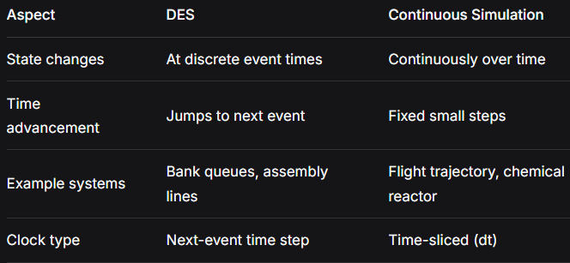
Feature | Discrete Distribution | Continuous Distribution
Values | Countable (0,1,2…) | Infinite range
Example | Poisson, Binomial | Normal, Exponential
Use | Number of arrivals | Time between events
Graph | Bars | Smooth curve

Q5: Queueing system? Explain single-server, single queue system with example.
Ans: Queueing system is a system in which customers or entities arrive over time, if service is not immediately available, they wait in queue. They receive service from one or more servers, after service completion, they exit the system.
COMPONENTS:
- Calling population: the group of customers that require service. Infinite population (bank customers) finite population (machines in a factory)
- Arrival process: describes how customers arrive at the system. Usually random in nature, inter arrival time.
- Queue/waiting line: if server is busy, customers must wait. FCFS, LCFS, Priority based.
- Service mechanism: number of servers (single or multi) service time (constant or random)
- Departure process: after service completion, cust must leave.
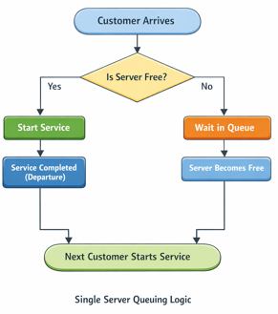
STEPS IN QUEUING SYSTEM
- Define the system: ex: bank with only one cashier and randomly arriving customers.
- Identify random variables: inter arrival time, service time.
- Generate random numbers: pseudo-random numbers generated by computer, used to calculate arrival and service times.
- Identify events; queuing system is a DES with 2 main events: arrival and departure event
- Advance simulation clock: clock doesn’t move continuously and jumps from one event to next.
- Collect statistics: waiting time of each cust, queue length, server idle and busy time.
ADVANTAGE:
- Realistic modelling
- Flexible
- Useful for system design
- Can test improvements before implementation
DISADVANTAGES:
- Time consuming
- Requires good ip data
- Results are approximate
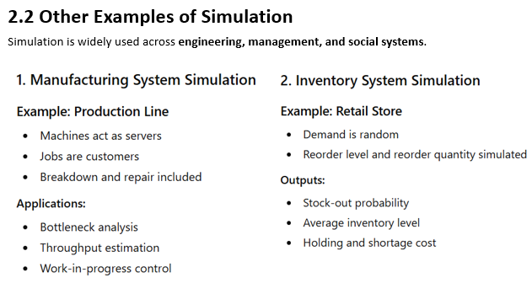

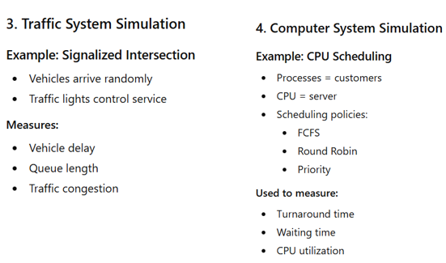
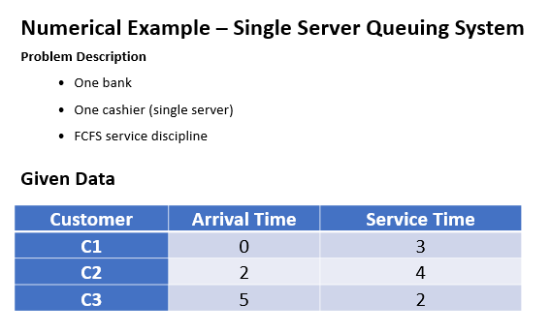
Q6. Grocery Store Simulation (5 customers)
Given:
- Interarrival time: 1–4 mins
- Service time: 1–4 mins
Let’s assume random values (since you weren’t given any, thanks question setter):
Customer | Interarrival | Arrival Time | Service Time | Start Time | End Time | Waiting Time
C1 | 0 | 0 | 3 | 0 | 3 | 0
C2 | 2 | 2 | 2 | 3 | 5 | 1
C3 | 1 | 3 | 4 | 5 | 9 | 2
C4 | 3 | 6 | 1 | 9 | 10 | 3
C5 | 2 | 8 | 2 | 10 | 12 | 2
Calculations:
- Avg Waiting Time = (0+1+2+3+2)/5 = 1.6 mins
- Server Utilization = Busy Time / Total Time = 12/12 = 100%
- Avg Service Time = (3+2+4+1+2)/5 = 2.4 mins
Q7. Applications + Complete Simulation Study
Applications of Simulation:
- Manufacturing (production lines)
- Healthcare (patient flow)
- Banking (queue systems)
- Transportation (traffic flow)
- IT systems (network performance)
Example: Hospital Emergency Room Simulation
1. Problem Definition:
Long waiting times in ER.
2. Objective:
Reduce patient waiting time.
3. Model Formulation:
- Entities: Patients
- Resources: Doctors
- Events: Arrival, treatment, discharge
4. Data Collection:
Arrival rates, service times
5. Model Implementation:
Use simulation software or code
6. Verification:
Check logic correctness
7. Validation:
Compare with real hospital data
8. Experimentation:
Test scenarios:
- More doctors
- Priority queues
9. Analysis:
Measure waiting time, utilization
10. Conclusion:
Choose best configuration
The system with:
- 2 servers + 1 common queue
has better efficiency than
- 2 servers + 2 separate queues
even if both servers have the same service rate.
Why?
With 1 common queue:
- customers go to the next available server automatically
- no server stays idle while another queue becomes long
- workload is balanced
- waiting time is reduced
With 2 separate queues:
- one queue may become overloaded
- one server may sit idle while customers wait in the other queue
- imbalance reduces overall efficiency
1 Server + Multiple Queues
Example:
- 1 barber
- 3 separate lines
Problems:
- One queue may become very long while another stays empty.
- Customers choose queues inefficiently.
- Server utilization may become uneven.
- More waiting time overall.
Result:
- Efficiency decreases
- Waiting time increases
- Queue management becomes poor

Multiple Servers + 1 Queue
Example:
- 3 billing counters
- 1 common queue
Advantages:
- Next free server takes the next customer immediately.
- Balanced workload among servers.
- Less waiting time.
- Better utilization.
Result:
- Efficiency increases
- Queue moves faster
- Better resource utilization
Steady State Behavior of Infinite Population Model
Definition
In an infinite population model, the number of customers/source population is assumed to be extremely large or unlimited. Customer arrivals are independent of the number already in the system.
The system reaches a steady state when:
- arrival rate and service rate become stable over time
- queue measures stop changing significantly
2. Markovian Models
Definition
A Markovian model is a queueing model where:
- arrivals follow Poisson distribution
- service times follow exponential distribution
- future state depends only on present state
This is called the memoryless property.
3. Steady State Behavior of Finite Population Model
Definition
In a finite population model, the number of customers is limited. The arrival rate depends on how many customers are already in the system.
The system reaches steady state when probabilities of different states become constant over time.
Definition
Statistical models are mathematical models used to represent real-world random systems and analyze uncertain events using probability and statistics.
They help in:
- prediction
- decision making
- simulation
- data analysis
Applications
- Queueing systems
- Inventory management
- Weather forecasting
- Machine learning
- Quality control
4.2 Discrete Distribution
Definition
A discrete probability distribution describes random variables that take only specific countable values.

Characteristics
- Finite or countable outcomes
- Probability assigned to each value
- Sum of probabilities = 1
4.3 Continuous Distribution
Definition
A continuous probability distribution describes random variables that can take any value within a range.

Characteristics
- Infinite possible values
- Measured quantities
- Probability represented by area under curve

